Introduction

The PLS Post Processor is executed every time the engineer “runs” a PLS analysis. The purpose of the post processor is to generate the following files and zip them into an archive for import into the Quote database:

* DXF files
  + Top view
  + Front view
  + Iso view
* PNG files – to be used on the SUEET engineering UI.
  + Top view
  + Front view
  + Iso view
* PLS postproc.xml
* PLS backup file – all files required to rerun the PLS analysis of the structure.

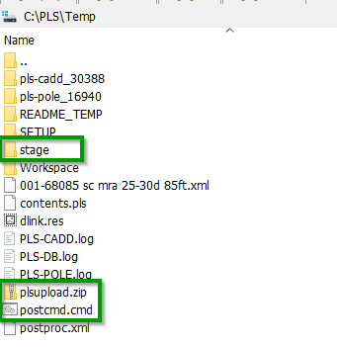The PLS Post Processor will create (see snapshot)

* One directory called “*stage”*. Contains all the files shown above including the PLS backup for this structure.
* One zip file called “*plsupload.zip*”, which contains all the files shown in the list above.
* One command file called “*postcmd.cmd*” used to execute PLS commands to create the DXF files.

PLS Post Processor Definition

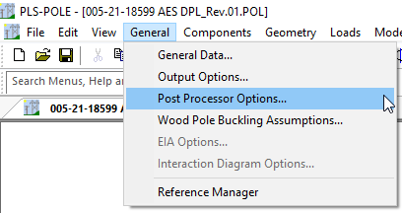The post processor is defined using the menu shown in the snap shot to the right.

Selecting *Post Processor Options* will pop up the dialog used to define the location of the executable..

The post processor executable (*plspp.exe*) is defined as shown in the green box below. The post processor is in [Q:\deploy\PlsPostProcessor](file:///Q:\deploy\PlsPostProcessor).

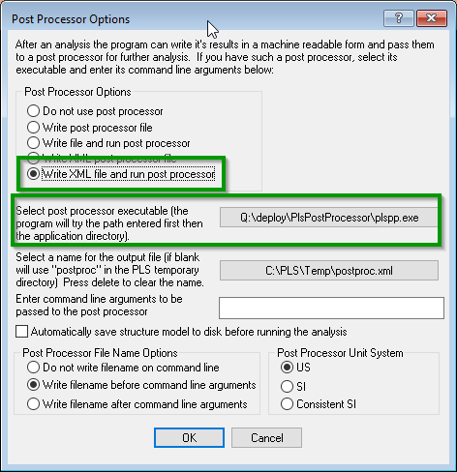To maintain the definition of the post processor, the engineer must save the .POL file. All subsequent runs of this PLS structure will execute the post processor for each PLS run.

If engineering uses a PLS structure template, the post processor may be defined here instead of having the define for each PLS job. The .POL file MUST be saved to define the post processor for each run.